**AP Calculus AB Name__________________________  
Mixed Integral W.S.**

**Evaluate**

1.  2. 

3.  4. 

5.  6. 

7.  8. 

9.  10. 

11.  12. 

**Find the derivative**

13.  14. 

15.  16. 

17. If , then  18. If then 

19. If **,**  20. If ,

then is increasing on what interval(s)? then is decreasing on what interval(s)?

21. If ,then  is? 22. Evaluate , if 

23. If, find 24. If , find 

**Find the average value.**

25.  26. 

27. on  28. on 



29. The average value of  on is 5. 30. The average value of a cont. function   
Find the value of  on the closed interval [3,7] is 12. What is the   
 value of 

Evaluate

31. If  32. If  then 

33. Givenfind  34. Given and find  
 

35. If is approximated by three **inscribed** rectangles of equal width on the x-axis, then the   
 approximation is ? (Hint: sketch and make sure each rectangle is inside the curve)  
a. 24 b. 26 c. 28 d. 48 e. 76

36. Let be the function given by  What is the least positive number , for which (use calculator, graph and use calculate zero)  
a. 1 b. 1.253 c. 1.571 d. 1.772 e. 3.142

|  |  |  |  |  |  |
| --- | --- | --- | --- | --- | --- |
|  | -2 | -1 | 0 | 1 | 2 |
|  | a | b | c | d | e |
|  | 2 | 4 | 6 | 8 | 10 |

37.

The table above gives values of a function and its derivative at selected values of . If is continuous on what is the average value of on the closed interval   
a.  b.  c.  d.  e. 

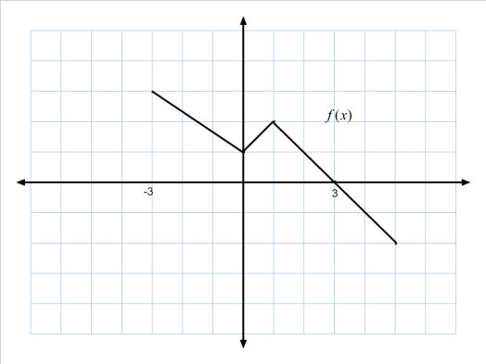

38. The graph of a piecewise function is shown to the right. If   
  which of the following has the greatest value?

a.  b.  c.  d.  e. 

39. 

40. A tank is being filled with water at the rate of gallons per hour with measured in hours. If the tank is originally empty, how many gallons of water are in the tank after 4 hours?

a. 600 b. 900 c. 1200 d. 1600 e. 2400

41. 

a. 0 b. 8 c. 13 d. 17 e. 21

42. Let *R* be the region in the fourth quadrant enclosed by the x-axis and the curve where *k* is a constant. If the area of the region *R* is 36, then the value of *k* is

a. -3 b. 3 c. 4 d. 6 e. 

43. If 

a. 60 b.  c.  d.  e. 

44. 

a. 12 b. 40 c. 46 d. 55 e. 66

45. If 

a. -16 b. -6 c. -4 d. 4 e. 16

**Mixed Integral W.S.  
Answers**

1.  2.  3.  4.  5. 5

6. no sol. (discount.) 7.  8.  9.  10. 

11.  12.  13. 

14.  15. 1 16.  17. 3 18. 

19. 20.  21.  22. 

23.  24.  25.  26. 

27.  28.  29.  30. 48

31.  32. 27 33.  34. 

35. b 36. b 37. b 38. d 39. 

40. d 41. c 42. b 43. e 44. b 45. e