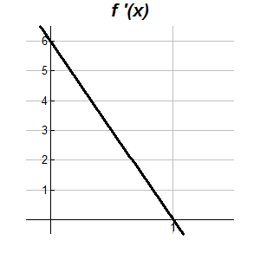**The Fundamental Theorem of Calculus Name__________________________  
Worksheet  
No Calculator Section**

1. The graph of , the derivative of , is the line shown in the figure above. If then 

2. A particle moves along the x-axis with the velocity given by for time  If the particle is at  
 position at what is the position of the particle at 

3. If is an antiderivative for and then 

a.  b.  c.  d.  e. -7+

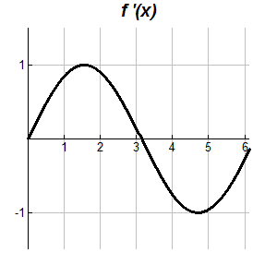

4. The graph of , the derivative of , is the curve shown in the figure above. If then 

|  |  |  |  |  |
| --- | --- | --- | --- | --- |
|  | 2 | 3 | 4 | 5 |
|  | 1 | 7 | 9 | 2 |

5. A table of values are given for . Use left Riemann Sums to approximate the value of given that 

6. A particle moves along the *x*-axis with the velocity given by for time  If the particle is at  
 position at what is the position of the particle at 

7. A differential function has the property that for and . Which of the following could be   
 true?

I.  II.  III. 

a. I only b. II only c. I and II only d. I and III only e. II and III only

**Calculator Active Section**

8. Let be the antiderivative of  If  then 

a. 0.048 b. 0.144 c. 7.827 d. 23.308 e. 5.827

9. A pizza, heated to a temperature of 350 degrees Fahrenheit (), is taken out of an oven and placed in a F room at   
 minutes. The temperature of the pizza is changing at a rate of degrees Fahrenheit per minute. To the   
 nearest degree, what is the temperature of the pizza at time minutes?

a. 112 b. 119 c. 147 d. 238 e. 335

10. A particle moves along the *x*-axis with the acceleration given by for time  If the velocity of   
 the particle is 2 at time  then the velocity of the particle at time is

a. 0.462 b. 1.609 c. 2.555 d. 2.886 e. 3.346

11. Water is pumped into a tank at a rate of gallons per minute, where *t* is the number of minutes   
 since the pump was turned on. If the tank contained 800 gallons of water when the pump was turned on, how much   
 water, to the nearest gallon, is in the tank after 20 minutes?

a. 380 b. 420 c. 829 d. 1220 e. 1376

12. A particle moves along a line so that its acceleration for is given by  If the particle’s velocity at   
 is 5, what is the velocity of the particle at 

a. 0.713 b. 1.134 c. 6.710 d. 6.134 e. 11.710

13. A cup of tea is cooling in a room that has a constant temperature of 70 degrees Fahrenheit (). If the initial   
 temperature of the tea, at time minutes, is 200and the temperature of the tea is changing at the rate   
 degrees Fahrenheit per minute, what is the temperature, to the nearest degree, of the tea after 4   
 minutes?

a. 175 b. 130 c. 95 d. 70 e. 45

14. The velocity of a particle moving along the *x*-axis is given by at time *t.* If the particle is at when   
 , what is the position of the particle when?

a. 2 b. 3 c. 4 d. 5 e. 6

15. At time  years, a forest preserve has a population of 1500 deer. If the rate of growth of the population is   
 modeled by  deer per year, what is the population at time 

a. 3987 b. 5487 c. 8641 d. 10,141 e. 12,628

Answers: 1. 6 2. 6 3. E 4. 4 5. 22 6. 13 7. C 8. C 9. A 10. E 11. D 12. E 13. A 14. B 15. D

**Answers**

1. 6
2. 6
3. E
4. 4
5. 22
6. 13
7. C
8. C
9. A
10. E
11. D
12. E
13. A
14. B
15. D